Testing plan: Coursework 17/18 step 4

Designed and executed by B00329768 Mikolaj Lukasik on 13/04/2018.

Table of Contents

1. Selection of product in “search by product type menu” 2

2. Selection of subtype in “search by product type menu” 3

3. Presentation of searched products 4

4. Selecting component to finish 5

5. Confirming component choice 6

6. Selecting finish type 6

7. Paint type input 7

# Selection of product in “search by product type menu”

## Expected result:

The program allows to choose a number from list of products. If the number is provided correctly, program goes on to selecting subtype.

## Actual result:

If the user inputs correct number, program lets user onto selecting subtype (ss1) or in case of universal products – will go on with showing search results (ss2). User can also write X or x to cancel (ss3). Any other alphanumeric or multisymbolic (ss4) input will not be accepted – program will display the selection again.

## Screenshots:

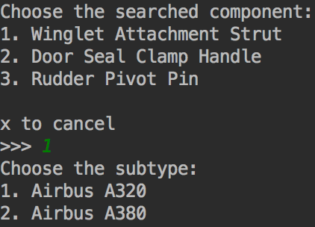

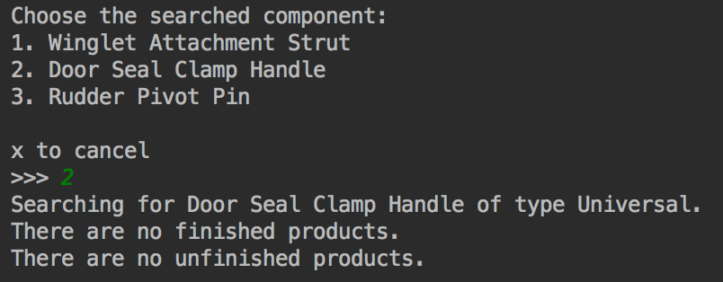

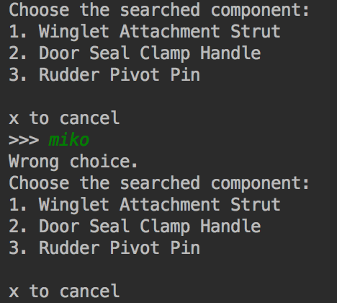

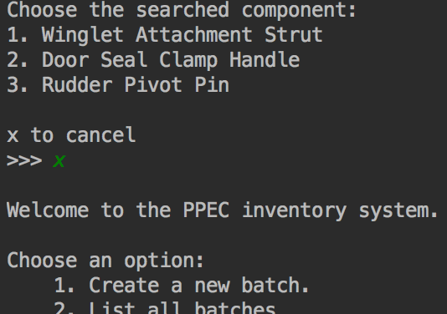

# Selection of subtype in “search by product type menu”

## Expected result:

The program allows to choose a number from list of subtypes. If the number is provided correctly, program goes on search results.

## Actual result:

If the user inputs correct number, program lets user onto search results (ss1) User can also write X or x to cancel and go back to main menu (ss2). Any other alphanumeric or multisymbolic (ss3) input will not be accepted – program will display the selection again.

## Screenshots:

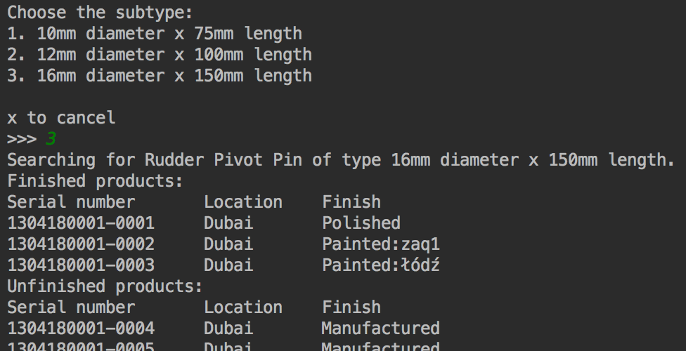

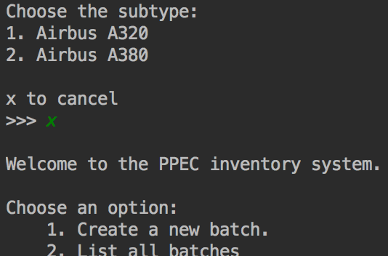

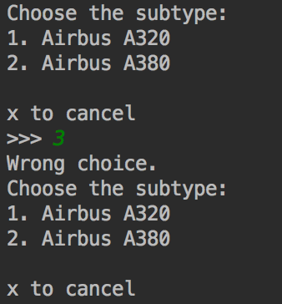

# Presentation of searched products

## Expected result:

Program will search for all components of desired type and subtype, then display their info.

## Actual result:

Program displays the searched product. Then it displays components in two parts: first finished products, then unfinished products. All data lines will show serial number of the product, its location and finish state.

Program informs the user if there are no desired products (ss1), just finished products (ss2), just unfinished products (ss3), or both finished and unfinished products (ss4).

## Screenshots:

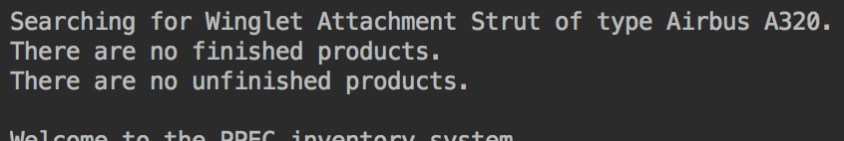

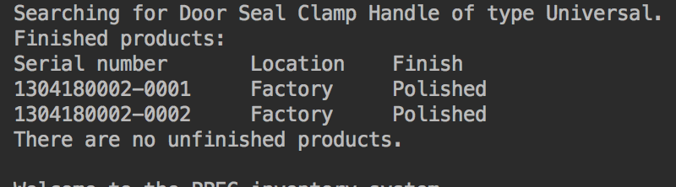

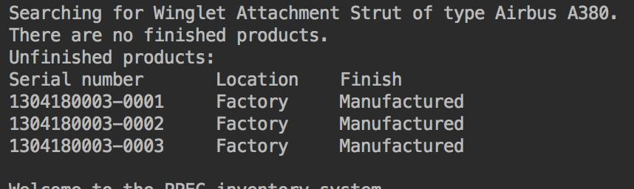

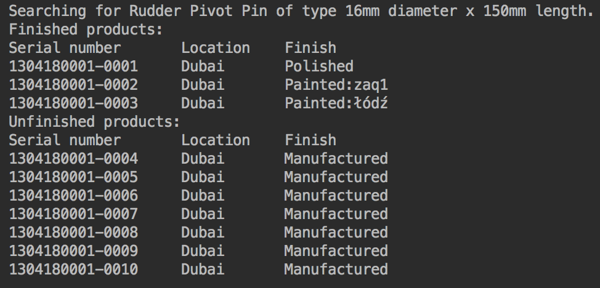

# Selecting component to finish

## Expected result:

Selecting “Finish a component” option will then prompt user for component ID number. If the correct number will be provided, then it will let user select the finish for the component.

## Actual result:

On correct component ID provided by user, program presents selected component’s type and subtype, then asks the user to confirm selection. (ss1)

Incorrect component ID, including all alphanumeric or multisymbolic input will result in error message (ss2).

Providing component ID of a part that already have been finished, will result in error message (ss3).

User can also go back to main menu simply selecting X (ss4).

## Screenshots:

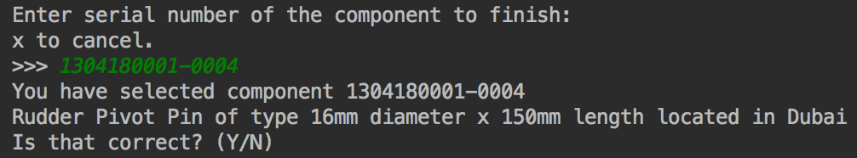

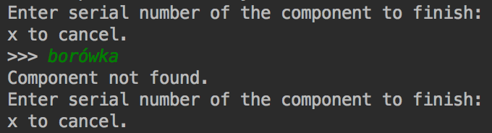

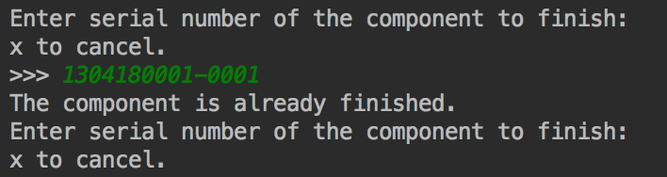

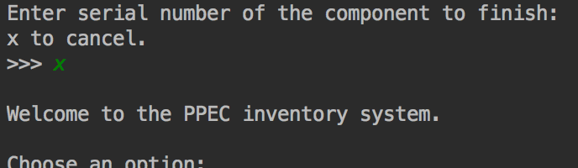

# Confirming component choice

## Expected result:

User is confirming the component choice and then goes on to selecting finish.

## Actual result:

On a correct confirmation (“Y” or “y”), the user will be let onwards to selecting finish. (ss1)

On any other input, alphanumeric or multisymbolic will return user back to component selection dialog. (ss2, ss3).

## Screenshots:

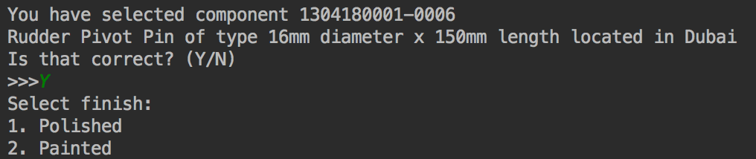

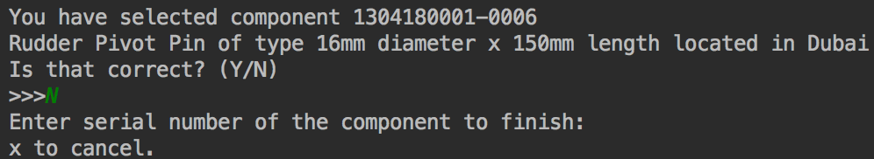

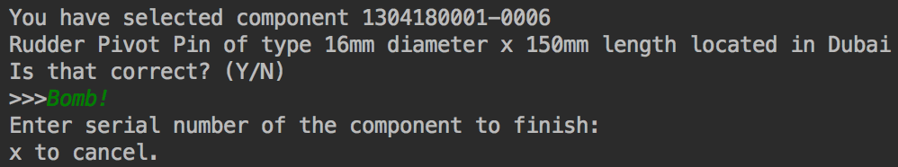

# Selecting finish type

## Expected result:

User is selecting the finish type for the component.

## Actual result:

Selecting first option will result in finishing the component with polish (ss1).

Selecting second option will take user to paint selection (ss2).

On any other input, alphanumeric or multisymbolic will result in error message (ss3).

## Screenshots:

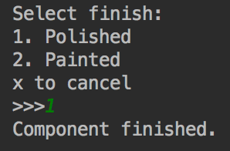

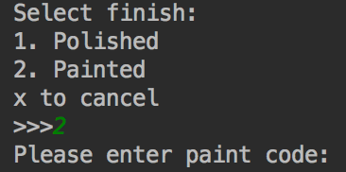

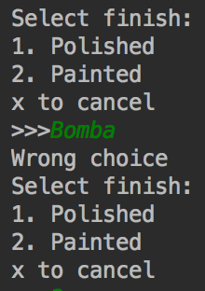

# Paint type input

## Expected result:

User is selecting the finish type for the component.

## Actual result:

Inputting 4 characters alphanumeric code will result in finishing component with this paint code (ss1, ss2).

On any other input, alphanumeric or multisymbolic will result in error message (ss3).

## Screenshots:

